**2022 – 2023 第一学期 实验报告**

课程编号： 2801000060， 课程名称：机器人学导论， 主讲教师： 邱国平

|  |  |  |
| --- | --- | --- |
| 学号：2022110131 | 姓名：廖祖颐 | 专业年级：大二 |

**Coursework 1 （20%）**

|  |
| --- |
| 教师评语/成绩 |

1. An explanation of the principle of binocular stereo vision using **your own language**. 300 – 800 字，可以加任意数量的图和表

**My understanding:**

From the human perspective, binocular stereoscopic vision is the ability of our brain to create a sense of depth and three-dimensional space from the different images captured by our two eyes.

From the machine perspective, binocular Stereo Vision involves using two cameras to take pictures of an object from different angles, then calculating the positional deviation between corresponding points in the images to obtain the three-dimensional geometric information of the object based on the principle of parallax.

Binocular stereo vision primarily involves four steps: camera calibration, stereo rectification, stereo matching, and parallax calculation.

1. **camera calibration**

In the process of generating a depth map, binocular calibration and polar alignment correction are typically essential to compensate for camera distortion and the potential non-coplanarity of the left and right images. However, in this experiment, the ground-truth disparities are obtained through a novel method utilizing structured lighting, eliminating the need for light projector calibration. Furthermore, the images undergo rectification, ensuring all image motion is strictly horizontal. This obviates the necessity for our own calibration and correction. As Figure 1.1 shown, we may use the camera matrix to help us calibrate camera, it includes information focal length (f x, f y) and optical center (c x, c y).

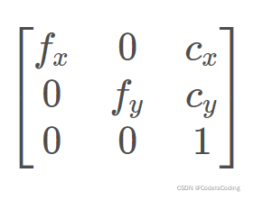

Figure 1.1

1. **stereo rectification**

As Figure 1.2 shown:

xl and xr is the abscissa of the image points in the left and right pictures

f is the focal length of the cameras

T is the distance between the two cameras

Z is the distance between the object and the shooting points connection

d represents to disparity and d=xl – xr.

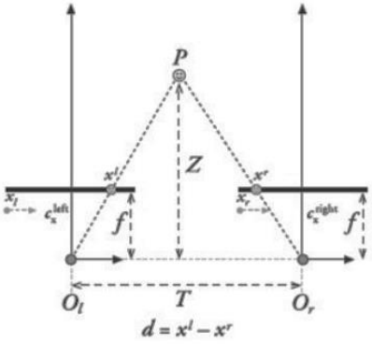

Figure 1.2

If we know the f and T, using triangle similarity theorem, we have formula (1,1) and formula (1,2) Through these formulas, we can calculate d and how it is far from each point in the image to the shooting point connection.

$$\begin{matrix}\frac{T}{T-(x^{l}-\frac{L}{2})-(\frac{L}{2}-x^{r})} & = & \frac{Z-f}{Z} & (1.1)\end{matrix}$$

$$\begin{matrix}Z & = & \frac{fT}{d} & = & \frac{fT}{x^{l}-x^{r}} & (1.2)\end{matrix}$$

Using Epipolar Constraints greatly reduces the matching range, making it easier to find corresponding points of the left image in the right image. For a pixel point p1 in the left image, we only need to search along the Epipolar line to surely find the corresponding point P2 of P1 in the right image.

Because we don’t know the parameters of the camera that took the picture in this experiment, my script just calculates the disparity, converts it to corresponding gray vlue and output a disparity map.

1. **stereo matching**

To find the disparity, if we use the gray value of single pixel to match, the result is usually inaccurate. But if we use a pixel window to represent a single pixel, and employ some algorithms to match the similarity between the windows in the left and right images, when the size of window is suitable, the result is more pleasant

In this experiment, I use three algorithm below:

1. SAD This algorithm is to subtract the gray values in the left and right windows and sum them. Finally, the disparity is when the sum is minimum. It’s formula is 1.3
$$SAD(k,l)=\sum_{i,j∈T}{ }|E(k+i,l+j)-E\left(k+i,l+d+j\right)| (1.3)$$

2. SSD This algorithm is to square the subtraction of gray values in the left and right windows and sum them. As SAD, the disparity is when the sum is minimum. It’s formula is 1.4.
$$SSD(k,l)=\sum_{i,j∈T}{ }|E\left(k+i,l+j\right)-E\left(k+i,l+d+j\right)|^{2} (1.4)$$

3. NCC This algorithm is much different from SAD and SSD. Its formula is to calculate the degree of correlation. Its value is range from -1 to 1 and the larger the value is, the higher the degree of correlation is. Its formula is 1.5.

$$NCC\left(k,l\right)=\frac{\sum_{i,j∈T}{ }\left(E\left(k+i,l+j\right)-\overset{\overline{}}{E}\left(k,l\right)\right)\left(E\left(k+i,l+d+j\right)-\overset{\overline{}}{E}\left(k,l+d\right)\right)}{\sqrt{\sum_{i,j∈T}{ }{\left(E\left(k+i,l+j\right)-\overset{\overline{}}{E}\left(k,l\right)\right)}^{2}\sum_{i,j∈T}{ }{\left(E\left(k+i,l+d+j\right)-\overset{\overline{}}{E}\left(k,l+d\right)\right)}^{2}}}$$

(1.5)

**(d).parallax calculation**

The algorithm traverses the right image to find the pixel block that "best matches" the left pixel block and calculates the horizontal displacement (i.e., disparity) between them. This horizontal displacement is recorded at the corresponding position in the disparity map. Like the Figure 1.3.

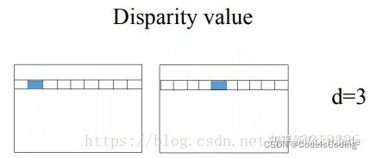

Figure 1.3

1. A detailed explanation of how you implemented your solution. 300 – 800 字，可以加任意数量的图和表

This script is designed for generating disparity maps from stereo images by using various similarity measures. Here's a concise overview of the solution:

1. **Library Imports:**

* cv2: Used for image processing.
* numpy: Handles numerical operations.
* time: Measures the performance of disparity calculations.

1. **Core Functions:**

* read_images: Loads and returns grayscale versions of stereo images.
* ncc, ssd, sad: Different functions for comparing image blocks, crucial for the script's adaptability in block matching.
* ncc: Uses Normalized Cross-Correlation, robust to lighting changes.
* ssd: Implements Sum of Squared Differences, emphasizing larger discrepancies.
* sad: Deploys Sum of Absolute Differences, known for its simplicity and speed.
* select_similarity_function: Determines the appropriate comparison method based on a given identifier, enhancing code maintainability.
* compute_disparity_map: The central function that conducts disparity computation. It's method-independent, working cohesively with any specified similarity measure.

1. **Main Execution Logic:**

* Sets file paths, block size, disparity range, and the similarity method.
* Calls read_images for input and compute_disparity_map for processing.
* Manages result visualization and performance measurement.
* Handles user interaction for display purposes.

1. import cv2
2. import numpy as np
3. import time
4. def read_images(left_image_path, right_image_path):
5. *# Read images in grayscale mode*
6. left_image = cv2.imread(left_image_path, 0)
7. right_image = cv2.imread(right_image_path, 0)
8. return left_image, right_image
9. def ncc(left_block, right_block):
10. *# Calculate the Normalized Cross-Correlation (NCC) between two blocks*
11. product = np.mean((left_block - left_block.mean()) * (right_block - right_block.mean()))
12. stds = left_block.std() * right_block.std()
13. if stds == 0:
14. return 0
15. else:
16. return product / stds
17. def ssd(left_block, right_block):
18. *# Calculate the Sum of Squared Differences (SSD) between two blocks*
19. return np.sum(np.square(np.subtract(left_block, right_block)))
20. def sad(left_block, right_block):
21. *# Calculate the Sum of Absolute Differences (SAD) between two blocks*
22. return np.sum(np.abs(np.subtract(left_block, right_block)))
23. def select_similarity_function(method):
24. *# Select the similarity measure function based on the method name*
25. if method == 'ncc':
26. return ncc
27. elif method == 'ssd':
28. return ssd
29. elif method == 'sad':
30. return sad
31. else:
32. raise ValueError("Unknown method")
33. def compute_disparity_map(left_image, right_image, block_size, disparity_range, method='ncc'):
34. *# Initialize disparity map*
35. height, width = left_image.shape
36. disparity_map = np.zeros((height, width), np.uint8)
37. half_block_size = block_size // 2
38. similarity_function = select_similarity_function(method)
39. *# Loop over each pixel in the image*
40. for row in range(half_block_size, height - half_block_size):
41. for col in range(half_block_size, width - half_block_size):
42. best_disparity = 0
43. best_similarity = float('inf') if method in ['ssd', 'sad'] else float('-inf')
44. *# Define one block for comparison based on the current pixel*
45. left_block = left_image[row - half_block_size:row + half_block_size + 1,
46. col - half_block_size:col + half_block_size + 1]
47. *# Loop over different disparities*
48. for d in range(disparity_range):
49. if col - d < half_block_size:
50. continue
51. *# Define the second block for comparison*
52. right_block = right_image[row - half_block_size:row + half_block_size + 1,
53. col - d - half_block_size:col - d + half_block_size + 1]
54. *# Compute the similarity measure*
55. similarity = similarity_function(left_block, right_block)
56. *# Update the best similarity and disparity if necessary*
57. if method in ['ssd', 'sad']:
58. *# For SSD and SAD, we are interested in the minimum value*
59. if similarity < best_similarity:
60. best_similarity = similarity
61. best_disparity = d
62. else:
63. *# For NCC, we are interested in the maximum value*
64. if similarity > best_similarity:
65. best_similarity = similarity
66. best_disparity = d
67. *# Assign the best disparity to the disparity map*
68. disparity_map[row, col] = best_disparity * (256. / disparity_range)
69. return disparity_map
70. def main():
71. *# Define paths for input images*
72. left_image_path = 'img1.png'
73. right_image_path = 'img2.png'
74. *# Load images*
75. left_image, right_image = read_images(left_image_path, right_image_path)
76. *# Record the start time*
77. tic_start = time.time()
78. *# Define the block size and disparity range*
79. block_size = 7
80. disparity_range = 64  *# This can be adjusted based on your specific context*
81. *# Specify the similarity measurement method ('ncc', 'ssd', or 'sad')*
82. method = 'sad'  *# Change this string to switch between methods*
83. *# Compute the disparity map using the selected method*
84. disparity_map = compute_disparity_map(left_image, right_image, block_size, disparity_range, method=method)
85. *# Resize the disparity map for display*
86. scale_factor = 3.0  *# Scaling the image by 3 times*
87. resized_image = cv2.resize(disparity_map, (0,0), fx=scale_factor, fy=scale_factor)
88. *# Display the result*
89. cv2.imshow('disparity_map_resized', resized_image)
90. print('Time elapsed:', time.time() - tic_start)
91. *# Wait for key press and close all windows*
92. cv2.waitKey(0)
93. cv2.destroyAllWindows()
94. if __name__ == "__main__":
95. main()

Note: The block_size is the same meaning of window_size in my script

1. A discussion on how different window sizes affect the results, and why. 300 – 800 字，可以加任意数量的图和表

To discuss how different window sizes affect the depth map, I set search range to 64 and the size of window to 3,5,7,15,21, then I got four images Fig 3.1, Fig 3.2, Fig 3.3, Fig 3.4, Fig 3.5.(Although this question we use algorithm SSD to answer, in SAD and NCC, we have the same conclusion.) (I use block_size instead of window_size in my script)

**Tips**: For typographical convenience, the depth maps in this part might not be clear. Please enlarge as appropriate in the file to view details.

And the time each experiment uses is shown in the table 3.1:

table 3.1

|  |  |
| --- | --- |
| window_size | Time(s) |
| 3 | 45.30 |
| 5 | 44.65 |
| 7 | 45.48 |
| 15 | 51.96 |
| 21 | 60.54 |

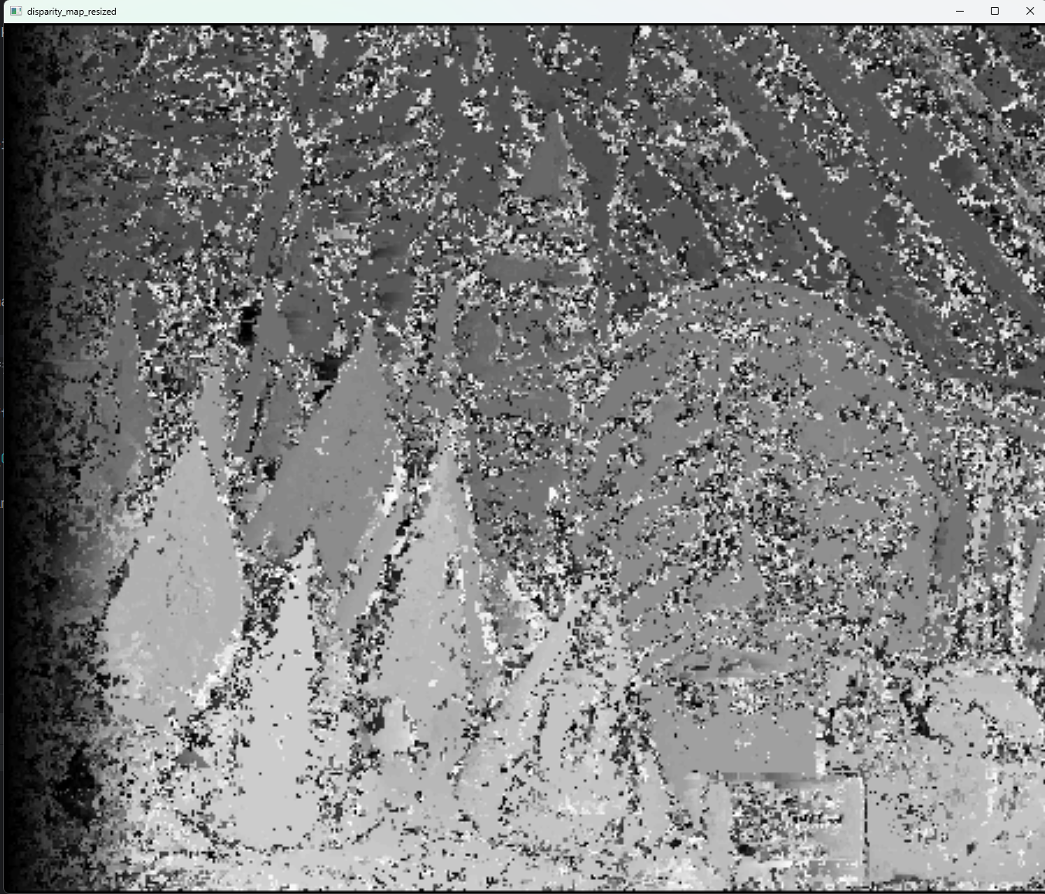 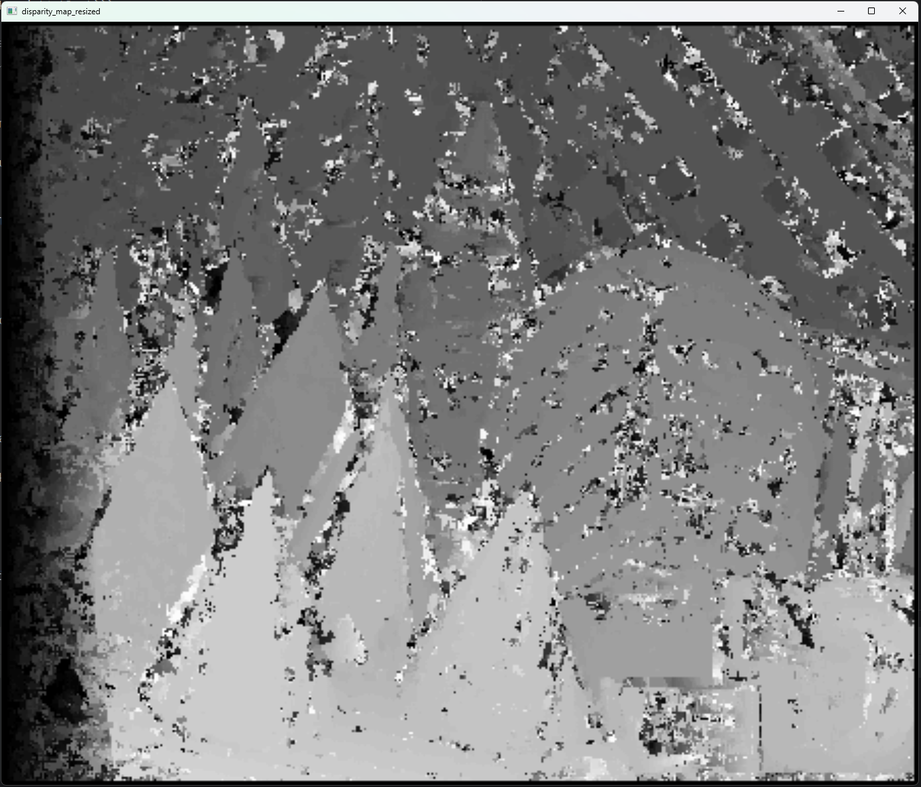

Fig 3.1,window_size=3 Fig 3.2,window_size=5

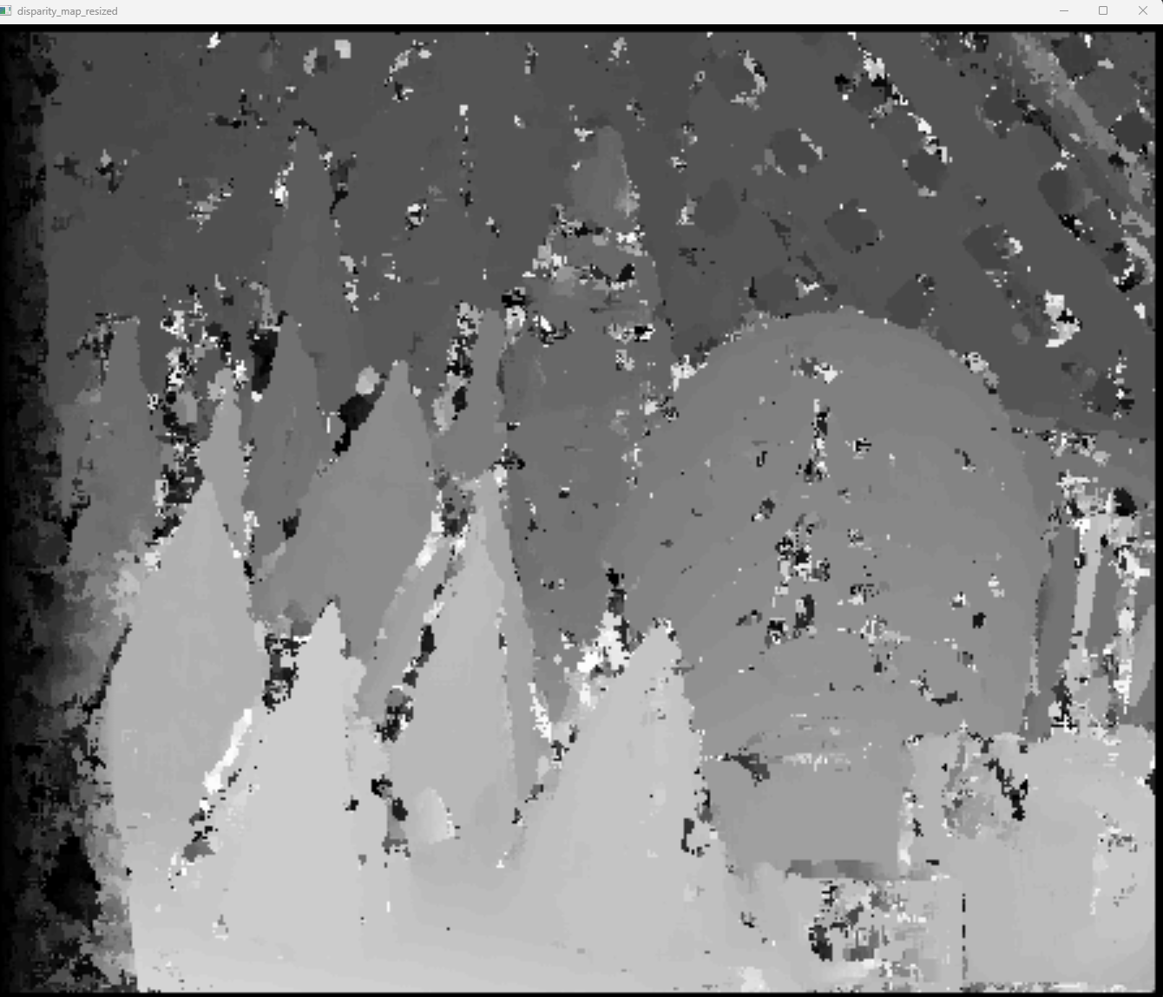 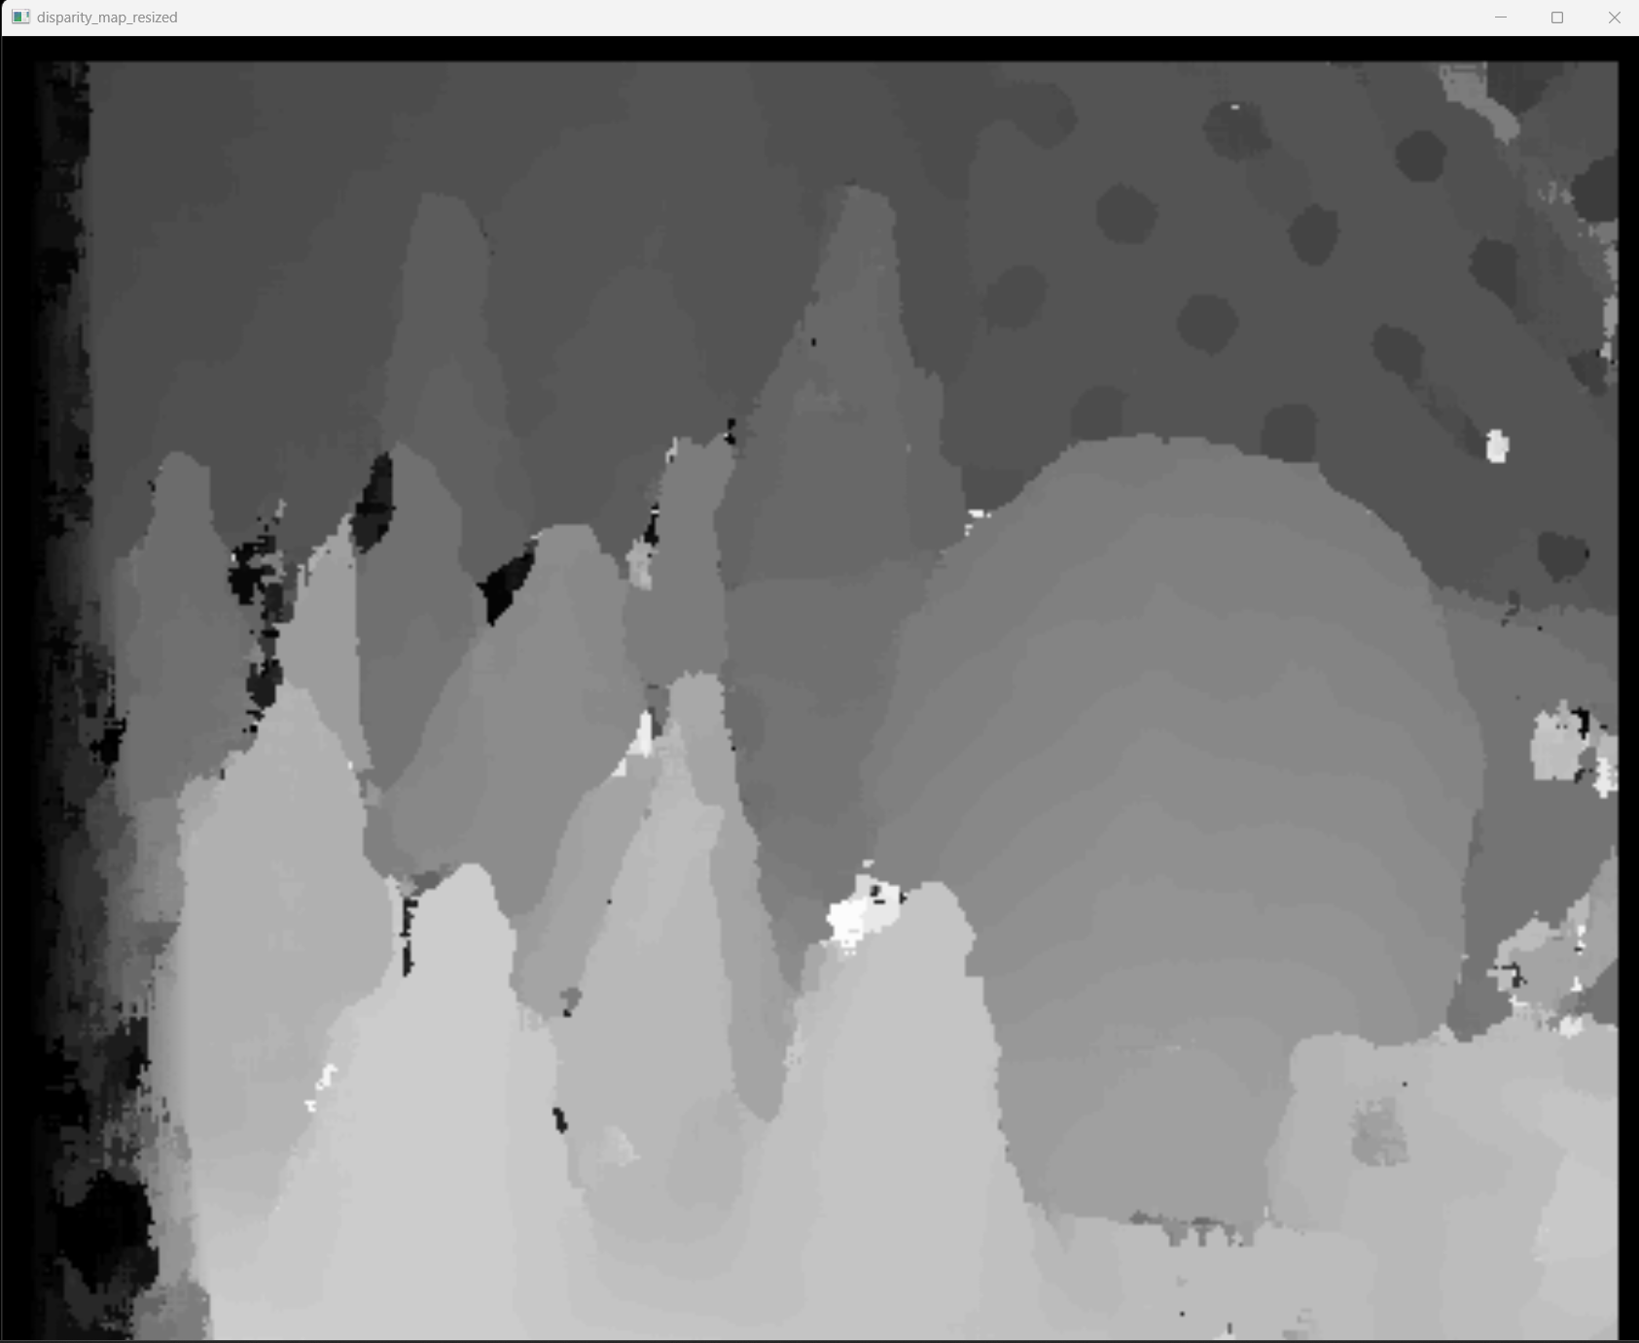

Fig 3.3,window_size=7 Fig 3.4,window_size=15



Fig 3.5,window_size=21

**Experimental Observations and Analysis:**

**Effect of Window Size:**

Initiating the experiment with an exceedingly small window size, such as 3, it was observed that while the contours of objects were distinctly visible, the depth map was significantly marred by noise. Incrementing the window size marginally to dimensions like 5 or 7 led to a noticeable reduction in noise. As the window size was expanded further, reaching 15 or 21, the noise dwindled to nearly imperceptible levels, rendering the image not only smoother but also imbued with a discernible sense of depth, allowing for an explicit demarcation between proximate and remote objects.

**Distortions at Larger Window Sizes:**

However, an unintended consequence of this scaling was observed. At larger window sizes, specifically 15 and 21, object morphology began to suffer distortions, with closer objects, notably the triangles in Fig 3.5, being the most adversely affected. Furthermore, finer details, like the apertures in a distant fence, were obscured or entirely lost.

**Timing Observations:**

In terms of computational duration, the experiments displayed inconsistency, with processing times fluctuating between 45 and 60 seconds, devoid of a discernible pattern correlating with window sizes or other parameters.

**Storage Space**

In the experiment, smaller window sizes produce noisier images with more details, using more storage (e.g., 126KB at size 3). Increasing the size reduces noise and storage use (109KB at size 5, 85.9KB at size 7) but blurs object edges and expands shadowed areas. Despite this, larger windows enhance depth continuity and lessen noise impact. However, they also introduce a growing black space at the depth map's right edge, indicating a trade-off between clarity and information retention.

**Rationale and Conclusions:**

**Small Window Drawbacks:**

An extremely small window size creates a situation where each point essentially functions independently, similar to attempting stereo matching using only the grayscale value of individual pixels across the left and right images, which is known for its inaccuracy.

**Large Window Complications:**

Conversely, an oversized window encapsulates an excessive number of pixels, diluting the impact of any single pixel's shift. Consequently, as the right window shifts slightly, the minimal variation in the window's content leads the algorithm to erroneously assume uniform disparity across neighboring points. This results in a depth map that, while smooth, is bereft of critical detail.

**Optimal Window Size:**

The experiment unequivocally demonstrates the profound impact of window size on the fidelity of the resulting depth map. Transitioning from smaller to larger sizes reveals a trend of diminishing noise and enhanced smoothness and layering in the image. For this experiment, given a disparity search range of [0,64], an optimal window size would likely fall between 7 and 15, balancing detail with noise reduction and overall image quality.

1. A discussion on the different similarity metrics you have used, explaining how they affect the results, and why. 300 – 800 字，可以加任意数量的图和表

To discuss how different similarity metrics affect the depth map, I set size of window to 3,7,15,21 in each experiment using different similarity metrics. Then we got four sets of results:

**Tips**: For typographical convenience, the depth maps in this part might not be clear. Please enlarge as appropriate in the file to view details.

1. **window_size=3**

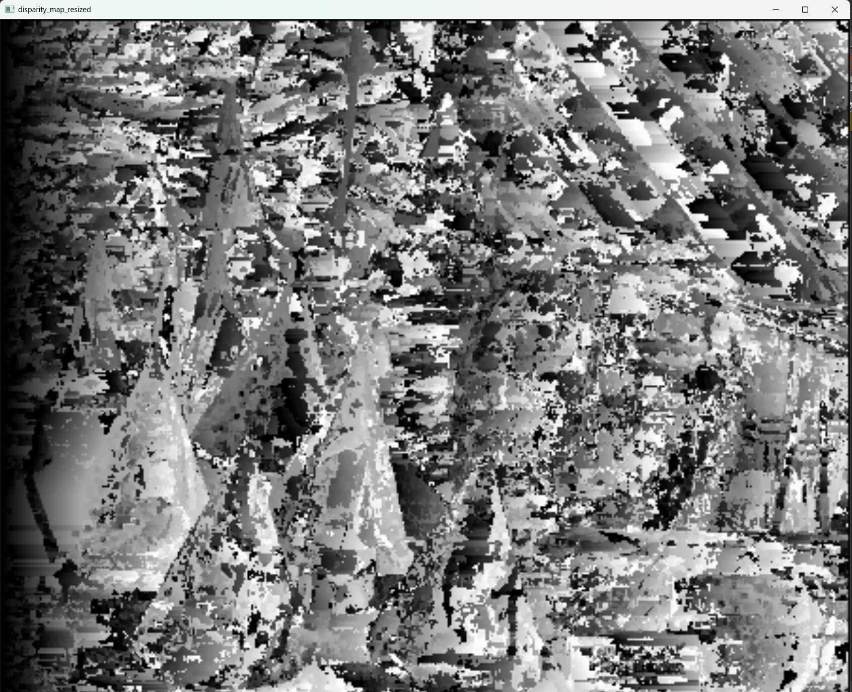 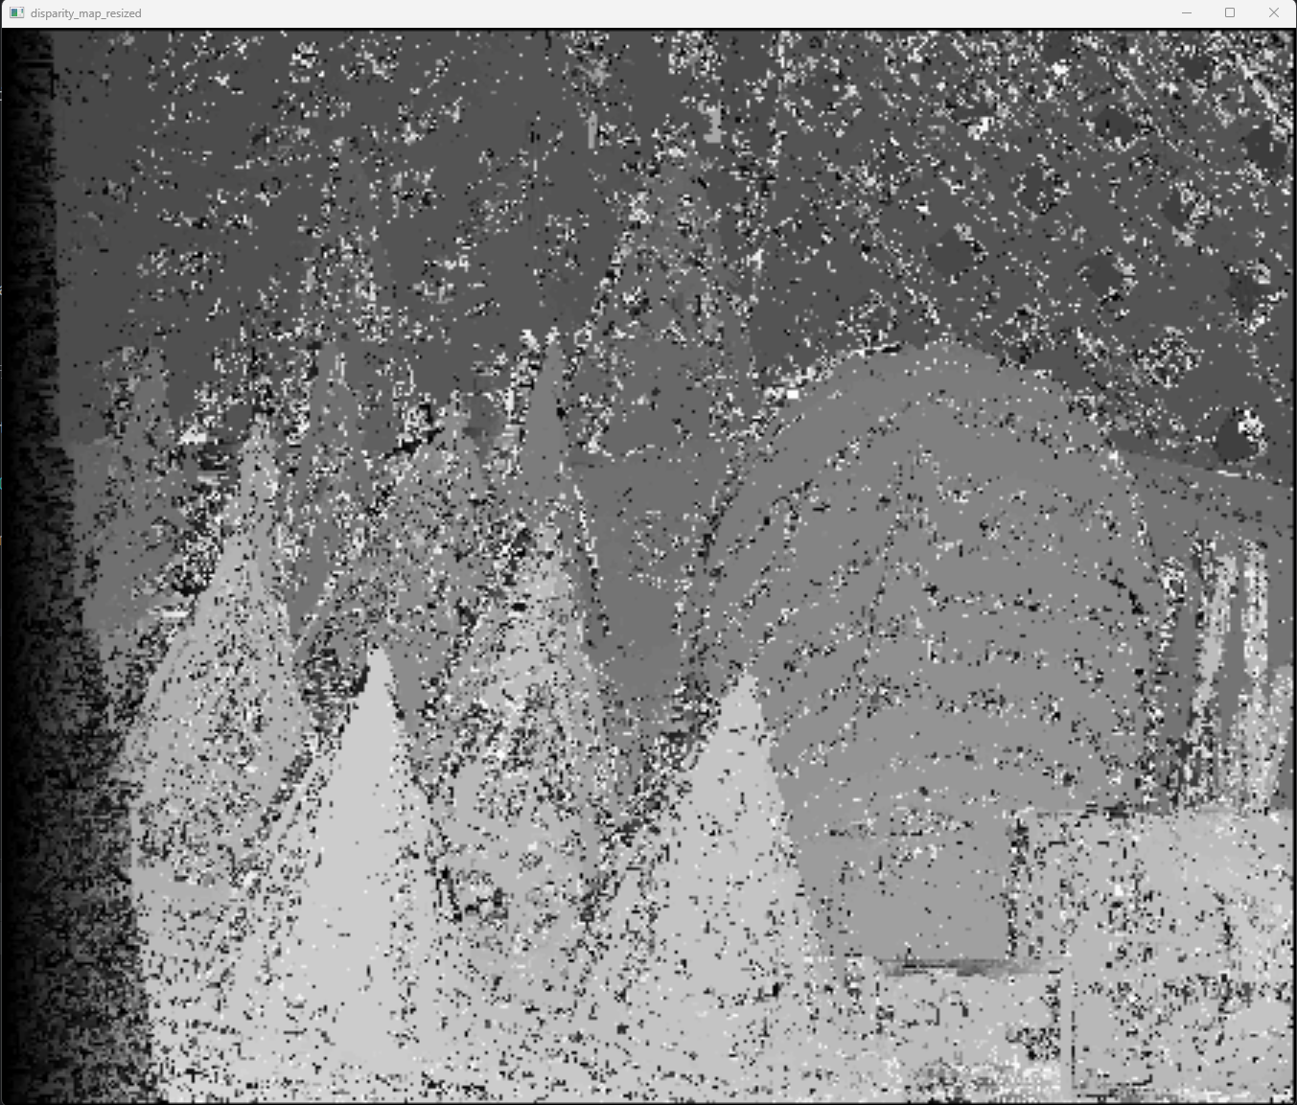 

Fig 4.1,SAD Fig 4.2,SSD Fig 4.3,NCC

And the time each algorithm used is shown in the table 4.1:

table 4.1,window_size=3

|  |  |
| --- | --- |
| Similarity metric | Time (s) |
| SAD | 41.99 |
| SSD | 45.30 |
| NCC | 379.97 |

1. **window_size=7**

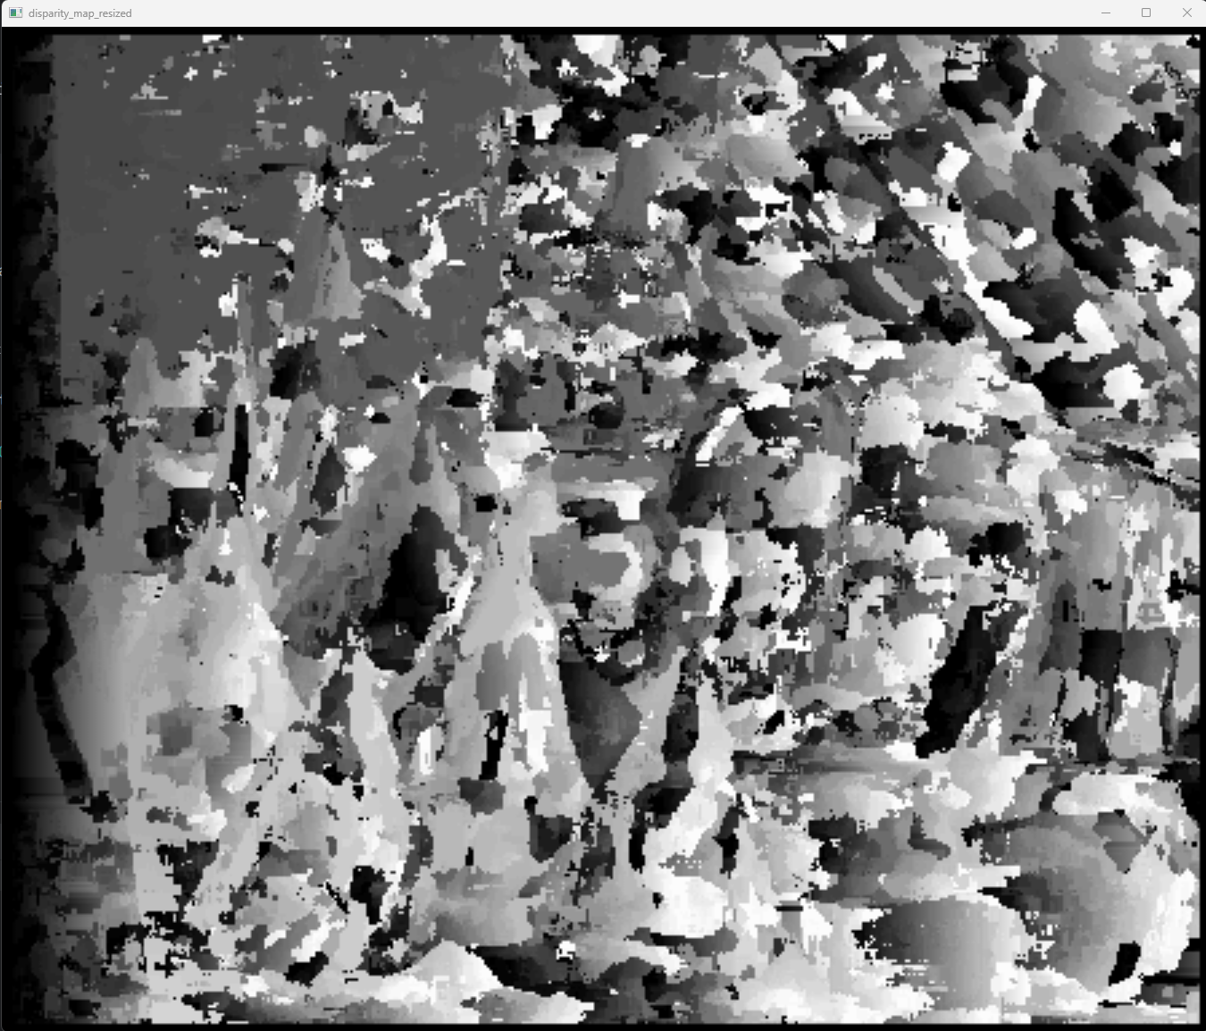  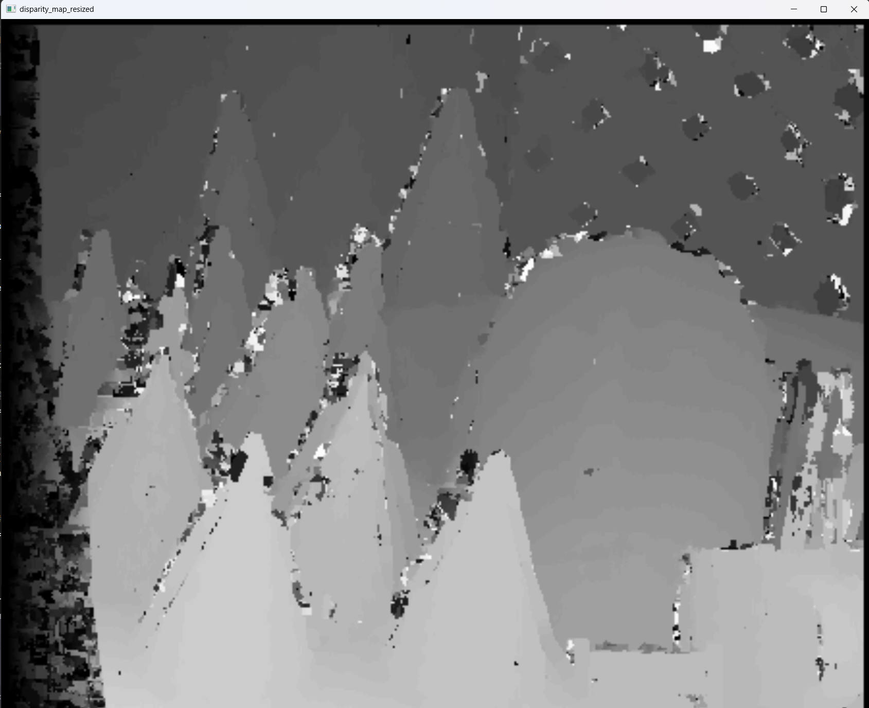

Fig 4.4,SAD Fig 4.5,SSD Fig 4.6,NCC

And the time each algorithm used is shown in the table 4.2:

table 4.2,window_size=7

|  |  |
| --- | --- |
| Similarity metric | Time (s) |
| SAD | 43.87 |
| SSD | 45.48 |
| NCC | 401.16 |

1. **window_size=15**

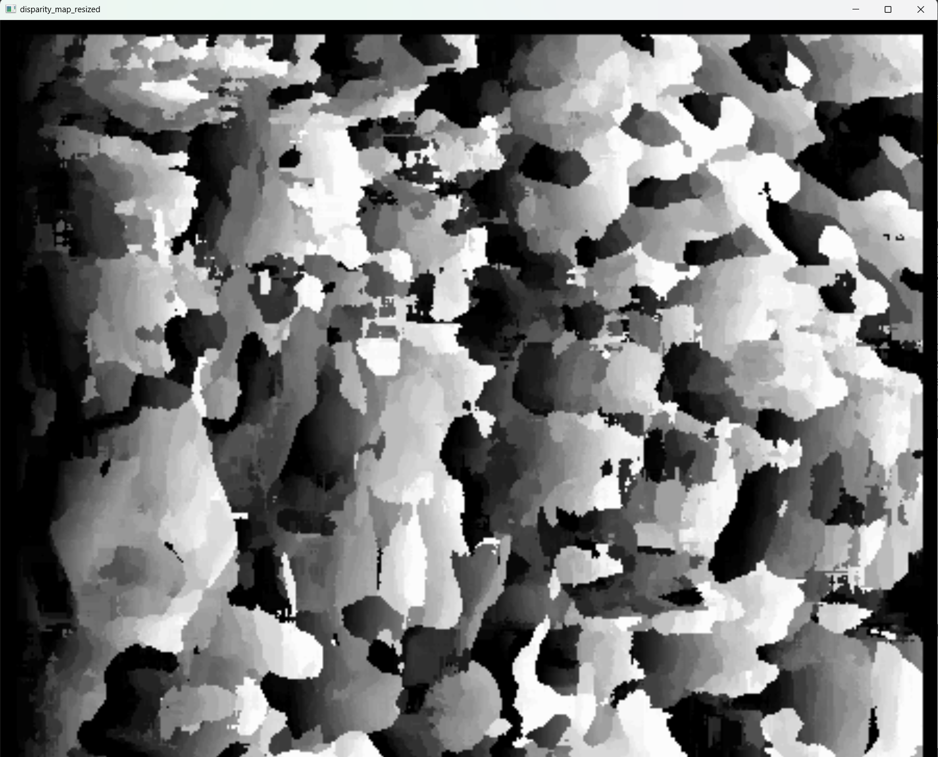  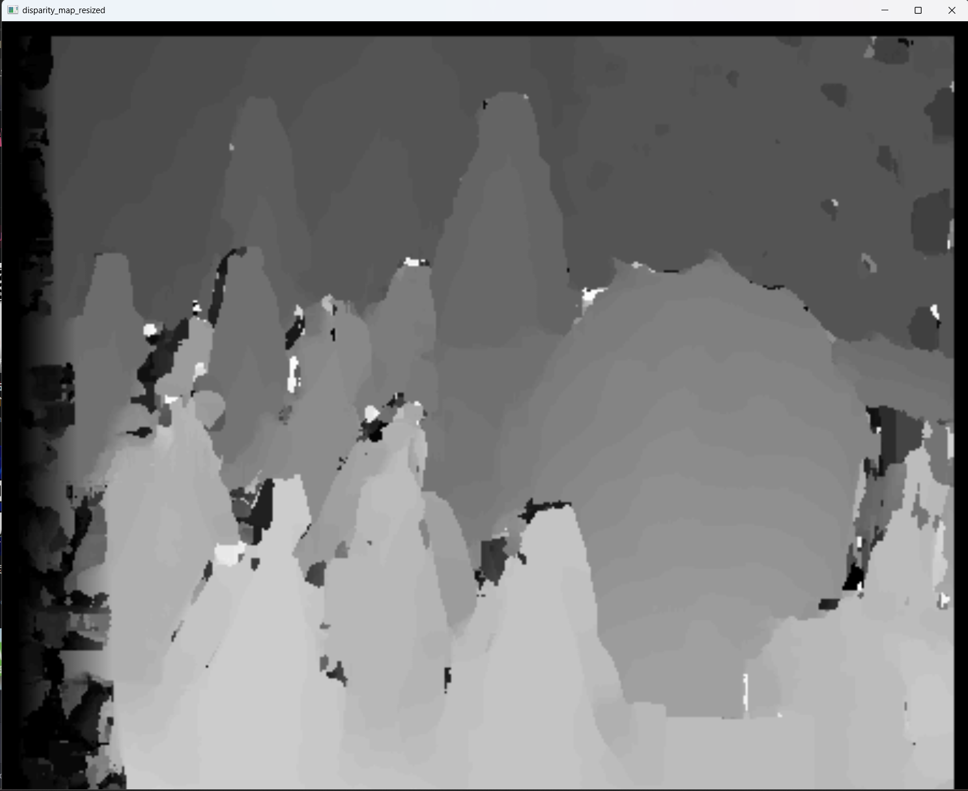

Fig 4.7,SAD Fig 4.8,SSD Fig 4.9,NCC

And the time each algorithm used is shown in the table 4.3:

table 4.3,window_size=15

|  |  |
| --- | --- |
| Similarity metric | Time (s) |
| SAD | 48.12 |
| SSD | 51.96 |
| NCC | 373.81 |

1. **window_size=21**

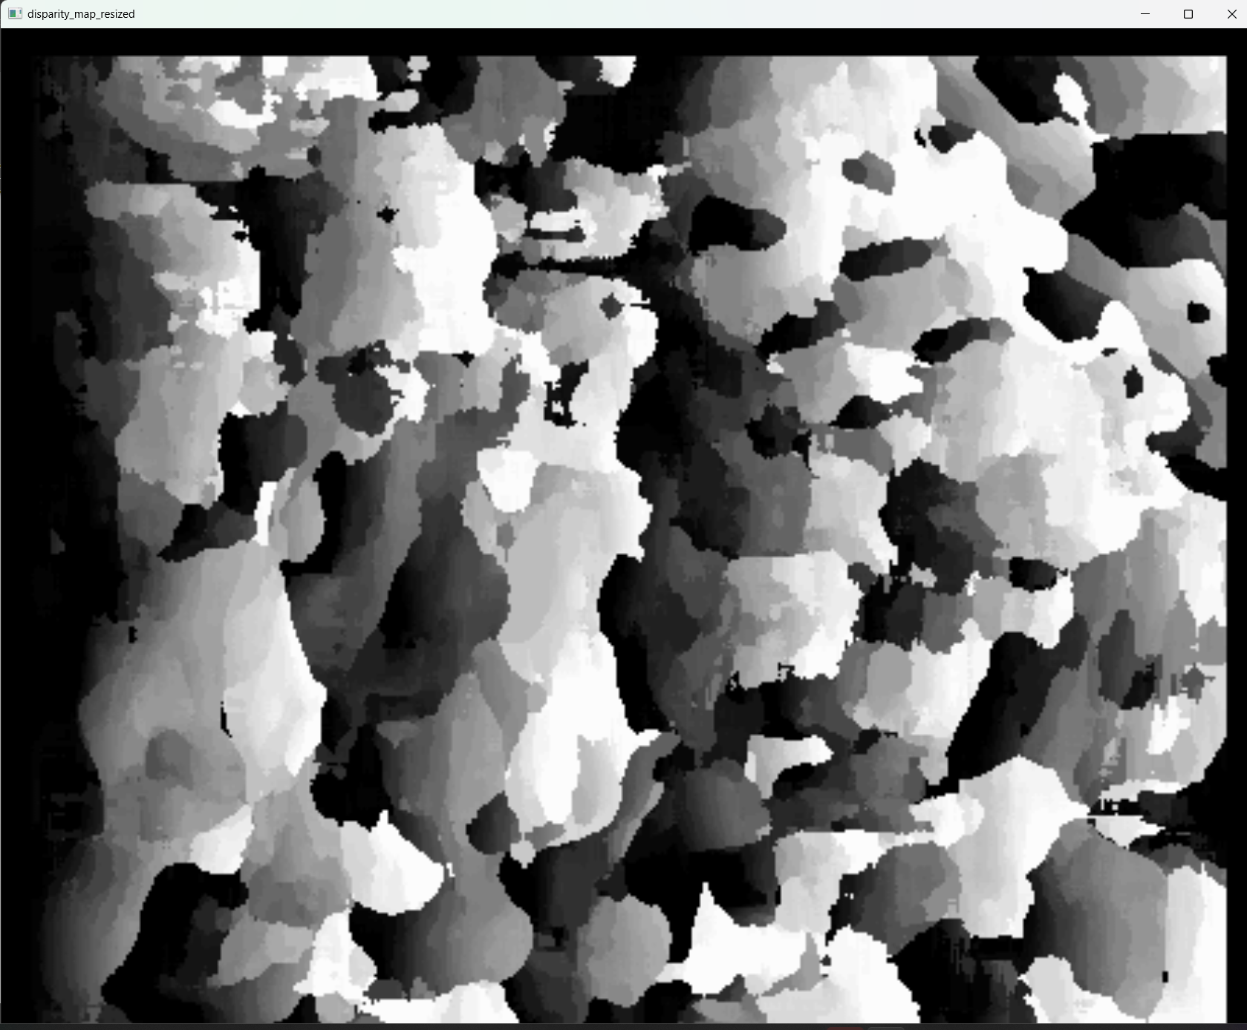 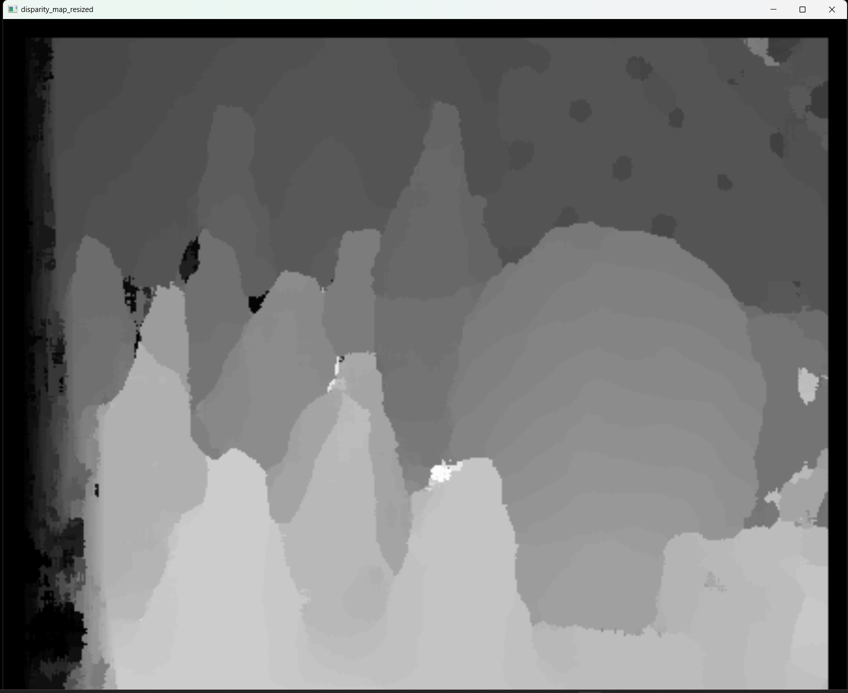 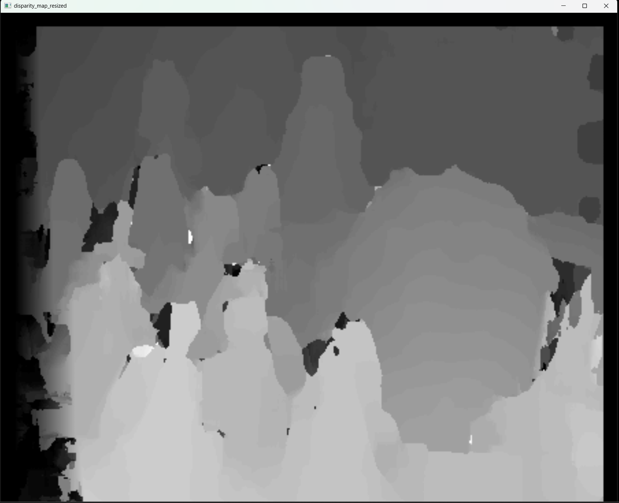

Fig 4.10,SAD Fig 4.12,SSD Fig 4.13,NCC

And the time each algorithm used is shown in the table 4.4:

table 4.4,window_size=21

|  |  |
| --- | --- |
| Similarity metric | Time (s) |
| SAD | 50.77 |
| SSD | 60.54 |
| NCC | 483.80 |

**Experimental Observations and Analysis:**

The SAD algorithm works poorly.

**Efficacy of the SAD Algorithm:**

The performance of the SAD (Sum of Absolute Differences) algorithm is found to be subpar. When utilizing a small window size, such as 3x3, all three algorithms (SAD, SSD, and NCC) tend to generate a significant amount of noise within the results. SSD (Sum of Squared Differences) manifests slightly fewer noise points compared to SAD, while NCC (Normalized Cross-Correlation) creates the highest number of noise points, significantly impacting the clarity of distant objects, such as fences.

**Error Manifestations:**

In the results from SAD and SSD, depth inaccuracies are typically presented as discrete points or clustered areas. In contrast, errors within NCC outputs are more uniformly distributed, appearing as dense, scattered points with fewer aggregations.

**Block Size Variations:**

Upon increasing the window size to dimensions like 7x7 or 15x15, SSD displays fewer inaccuracies, particularly on objects closer to the viewpoint, although some regions demonstrate exaggerated errors. NCC, in comparison, delivers a smoother representation of distances for farther objects, as seen in Fig 4.6, despite a more pronounced granularity in the disparity map. When the window size is expanded to 21x21, SAD yields fewer noise points than SSD and NCC, though all three algorithms introduce some distortion into the object shapes.

**Computational Time:**

NCC consistently demands the most substantial computational time, with SAD and SSD completing more quickly across all tested scenarios.

**Rationale and Conclusions:**

**Algorithmic Complexity:**

Assessing formulas 1.3 through 1.5, it’s evident that NCC's computational demands are considerably higher than those of SAD and SSD, attributable to its more complex correlation calculations, thus leading to longer processing times.

**Inaccuracies in NCC:**

The notable error area within the NCC map, especially around the large triangle, could be due to an inadequate search range. As the algorithm processes the left image from left to right, it initially locates the leftmost point of the green triangle. However, the search range's limitations prevent it from identifying the optimal match, resulting in a premature selection of a match point. This miscalculation translates into a disparity that understates the actual one, evidenced by the darker points indicating lesser disparity.

**Optimal Algorithm Selection:**

Based on repetitive trials, the SSD or NCC algorithms with a moderate 7x7 to 15x15 block size are recommended for more precise outcomes, or the SAD algorithm with a smaller 3x3 window size for acceptable results with less computational demand.